Lora-Based Rover for Planetary Exploration Adapting Surveillance Spy Robot for Space Sample Detection
R Suriyamoorthy
Electronics And Communication Engineering
AAA College Of Engineering And
Technology
Sivakasi, Tamilnadu, India
21rec047@Aaacet.Ac.In
R Sivabalan
Electronics And Communication Engineering
AAA College Of Engineering And
Technology
Sivakasi, Tamilnadu, India
21rec044@Aaacet.Ac.In
T Philip Allwyn
Electronics And Communication
Engineering
AAA College Of Engineering And
Technology
Sivakasi, Tamilnadu, India
philip@aaacet.ac.in
P Saravanakumar
Electronics And Communication
Engineering
AAA College Of Engineering And
Technology
Sivakasi, Tamilnadu, India
saravanakumar@aaacet.ac.in

Abstract
This Paper Demonstrates The Modification Of Spy Robot Into Rover Robot For Space Sample Detection. The Rover Is Upgraded With The Data Transmission And Communication Capabilities. The Lora Technology With Alien Technology Is Used To Implement The Long Distance Communication In This Research. The Extensive Investigation Of Navigation, Sample Detection And Integration Of Space Graded Components Also Given In This Paper. All The Simulations Are Done In The Space Environment Towards The Space Application.
Key Words: Sample Detection, Lora, Rover, Space Exploration.
I. Introduction
Lora (Long Range) Technology Stands As A Hallmark Of Innovation In The Realm Of Wireless Communication, Particularly Suited For Applications Demanding Long-Range, Low-Power Connectivity[1]. Leveraging The Unlicensed Radio Spectrum, Lora Facilitates Robust, Long-Distance Communication, Transcending Traditional Barriers Encountered By Other Wireless Technologies. Its Distinctive Modulation Technique Allows For Exceptional Sensitivity, Enabling Communication Over Several Kilometers In Range, Even In Challenging Environments[2]. Lora Finds Diverse Applications Across Various Domains, Including Smart Cities, Agriculture, Industrial Automation, And Environmental Monitoring[3]. Its Efficiency In Transmitting Small Packets Of Data Over Extended Distances With Minimal Power Consumption Makes It An Ideal Choice For Iot (Internet Of Things) Deployments, Where Devices Need To Operate Autonomously For Extended Periods. The Adaptability And Scalability Of Lora Technology Continue To Drive Innovation, Fostering A Connected World Where Data Can Be Seamlessly Collected And Transmitted, Facilitating Smarter Decision-Making And Enhancing Efficiency Across Industries. Lora Technology Has Emerged As A Leading Solution For Internet Of Things (Iot) Applications Due To Its Operation Within The Unlicensed Industrial Scientific And Medical (ISM)[4] Band, Providing Long-Range Connectivity To Low-Power Devices. Originally Developed For Military Communication In The 1940s, Lora Has Evolved Into A Reliable Platform For Real-Time Data Monitoring And Transmission. In Defense Applications, Lora's Chirp Spread Spectrum Modulation Offers Advantages Over Traditional Methods, Allowing For Efficient Use Of Low-End Oscillators And Improved Synchronization Reliability[5]. With A Link Budget Exceeding 150 Db, Lora Ensures Extensive Coverage, Making It Ideal For Surveillance And Monitoring Purposes.
The Fundamental Principle Of Chirp Spread Spectrum Modulation Involves Converting Information Into Bits And Spreading It Across The Spectrum, Maximizing Channel Utilization And Signal Effectiveness[6]. Lora Technology Addresses Various Iot Challenges By Minimizing Duplicates, Reducing Device Costs, Extending Battery Life, Enhancing Network Capacity, And Accommodating A Larger Number Of Connected Devices. Its Transmission Range Spans Approximately 10 To 15 Km In Rural Areas And Up To 30 Km Over Water, With Data Rates Typically Ranging From A Few Hundred To A Few Thousand Bits Per Second (0.3 To 37.5 Kbps). This Optimization Of Power Consumption Helps Prolong Device Battery Life[7]. In Comparison To Other Technologies Like GSM, Zigbee, Wi-Fi, And Bluetooth, Which Often Require Higher Power Consumption, Lora Offers An Energy-Efficient Solution For Iot Applications. This Is Particularly Relevant In India, Where The Deployment Of Iot-Enabled Robots In Cognitive Stations Requires Prolonged Operational Capability In Highly Unstructured And Dynamic Natural Environments. These Robots Need To Process Large Amounts Of Data Quickly And Make Informed Navigational Decisions, Highlighting The Importance Of Leveraging Lora TECHNOLOGY [7][8]. Lora (Long Range) Technology Is Pivotal For The Seamless Operation Of Spy Robots Deployed For Planetary Exploration. Leveraging Its Robust Long-Range Communication Capabilities, Lora Enables These Robots To Maintain Continuous Contact With Their Base Stations Or Control Centers, Even Across Vast Distances And Challenging Terrain. By Utilizing Lora, Spy Robots Can Transmit Crucial Data, Such As Environmental Conditions, Geological Findings, And Potential Hazards, Back To Their Operators In Real-Time, Facilitating Informed Decision-Making And Enhancing The Efficiency Of Exploration Missions. This Technology Ensures That Spy Robots Remain Connected And Responsive, Empowering Scientists And Engineers To Delve Deeper Into The Mysteries Of Distant Planets With Confidence And Precision.

XXX-X-XXXX-XXXX-X/XX/$XX.00 ©20XX IEEE

II Proposed System
The Proposed System Utilizes A Cognitive Robot For Covert Surveillance, Building Upon Previous Concepts Of Remotely Operated Unmanned Ground Vehicles (Ugvs) That Have Been Developed For Tasks Such As Path Tracking, Mine Detection, Human-Animal Detection, And Visual Surveillance. In This Work, The Cognitive Robot Is Designed To Perceive Its Environment, Collect Relevant Data, And Transmit It To A Base Station For User Intervention. To Handle The Substantial Amount Of Data Collected By Its Sensors, The Cognitive Robot Must Undergo Various Processing Steps, Including Filtering And Organizing The Information Before Executing Mission-Specific Tasks. Multiple Sensors Are Integrated Into The Robot To Assess Environmental Conditions, Including Detecting Harmful Gases, Identifying Human And Animal Presence, And Detecting Metals. At The Core Of The Robot Lies The ESP32 Microcontroller, Which Orchestrates All Operations. A Metal Detector Is Incorporated For Mine Detection And Identifying Nearby Weaponry Or Equipment, Potentially Deployed In The Field Or By Adversaries. PIR Sensors Are Utilized For Human And Animal Detection, Promptly Alerting The User Through Notifications Displayed On An OLED Screen Upon Detecting Any Unusual Behavior.

III. Block Diagram Of Methodology And Remote Control.
1The robot side of the system uses ESP32 and the controller side of the system ESP32. ESP32 is a low-cost,
low-power Microcontroller with an integrated Wi-Fi and Bluetooth.
2. Various sensors such as Metal Detector Sensor to detect any metal, land mines , guns varios metal obstacles,
2.1 IR Sensor (Human Detection) sensors use a pair of pyroelectric sensors to detect heat energy in the
surrounding environment. These two sensors sit beside each other, and when the signal differential between the
two sensors changes (if a person enters the room, for example), the sensor will engage. It can be used to detect
any humans or animals in the vicinity.
2.2 Metal Sensor to detect any weapons or ammunitions in the vicinity.
2.3 Gas Sensor (Hazardous Gas Detection) is a device which detects the presence or concentration of gasses in
the atmosphere. It is helpful to detect toxic or explosive gasses and measure gas concentration.
Fig -1: Block Diagram of Robot
3. The L293D Motor Driver is used to drive engines connected to a robot.
4. LoRa SX1278 modules are used to transfer data between the modules.
5. Data from the sensors connected to the robot is collected and transmitted by LoRa via the robot to the LoRa
controller.
6. The joystick is used as a controller to control the movement of the robot.
7. Robot navigation is done via the Wi-Fi module.
8. The 2C LCD is used to display the current state of the sensors sent by the robot to the controller.

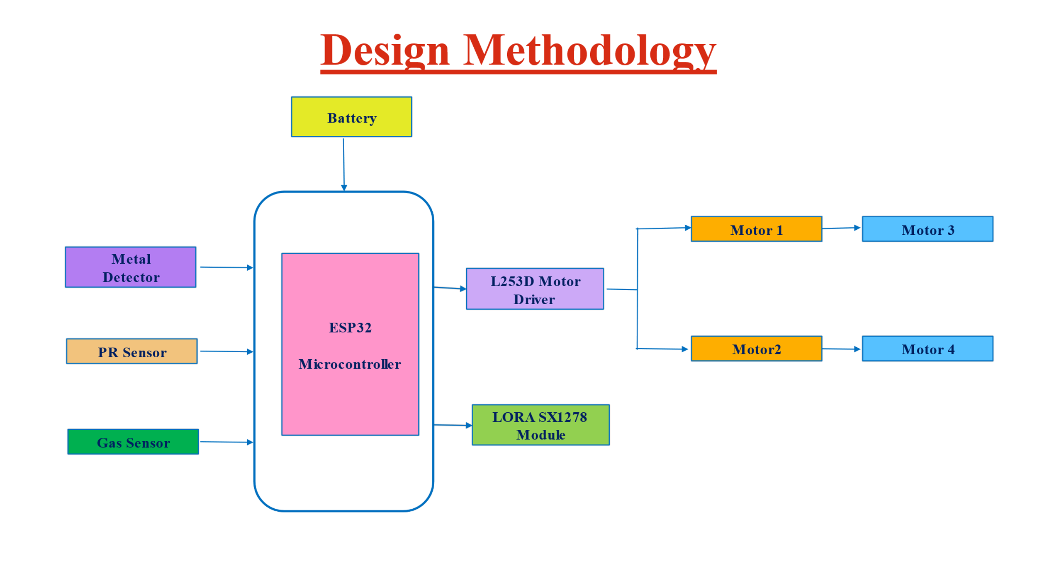

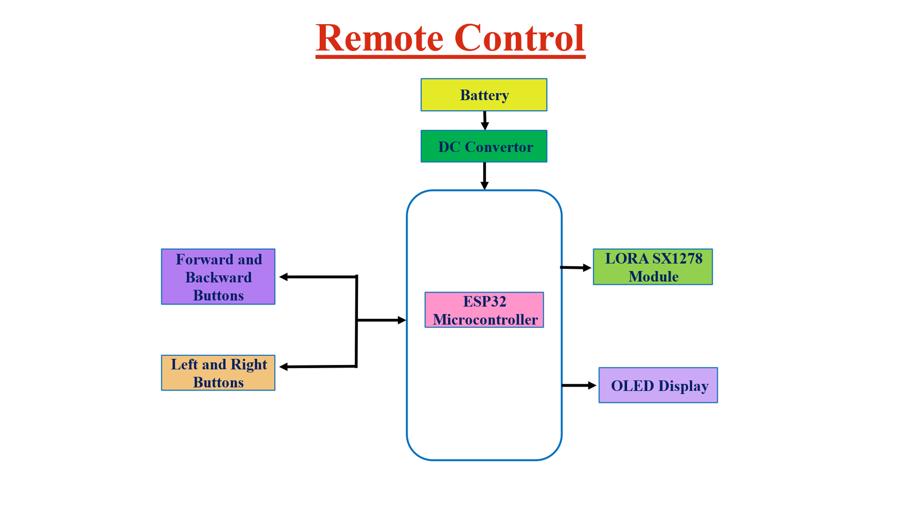

Result

In this study, a framework for transforming a spy robot into a rover robot capable of space sample detection is developed and demonstrated. The rover is enhanced with advanced data transmission and communication capabilities, specifically utilizing LoRa technology in conjunction with Alien technology to achieve long-distance communication. The research thoroughly investigates navigation, sample detection, and the integration of space-graded components, ensuring the rover's functionality in a simulated space environment.
Additionally, the study addresses the necessity of devices capable of long-range communication and energy efficiency, a critical aspect given the rapid development in the Internet of Things (IoT). By leveraging LoRa communication techniques, the modified rover effectively overcomes the challenge of limited range surveillance, making it suitable for military surveillance purposes even in areas with no network coverage.
The simulations conducted in a space environment validate the rover's application in space missions, highlighting its potential for future space exploration and military applications.
Conclusion
This Work Presents The Development Of A Cognitive Spy Robot Tailored For Military Surveillance Purposes. Leveraging Advancements In Iot Technology, The Robot Utilizes Lora Communication Techniques To Enable Long-Range Communication In Areas With Limited Or No Network Coverage. It Offers Remote Operability, Allowing Manual Control Via Mobile Devices And Automated Monitoring Through Programmed Routines. Its Compact Size Enables Maneuverability In Areas Inaccessible To Humans, Enhancing Its Effectiveness In Surveillance Missions. This Project Demonstrates The Practical Application Of Iot-Enabled Solutions In Enhancing Military Surveillance Capabilities Providing A Valuable Asset For Monitoring And Reconnaissance Operations.

References
[1] A. S. Rawat, J. Rajendran, H. Ramiah, And A. Rana, “LORA (Long Range) And LORAWAN Technology For Iot Applications In Covid-19 Pandemic,” Proc. - 2020 Int. Conf. Adv. Comput. Commun. Mater. ICACCM 2020, Vol. 2020-Augus, No. November, 2020, Doi: 10.1109/ICACCM50413.2020.9213067.
[2] A. Farhad And J. Y. Pyun, “Lorawan Meets ML: A Survey On Enhancing Performance With Machine Learning,” Sensors, Vol. 23, No. 15, 2023, Doi: 10.3390/S23156851.
[3] B. Setiawan, E. S. Putra, I. Siradjuddin, M. Junus, D. Dewatama, And S. Wiyanto, “Study Of Lora (Long Range) Communication For Monitoring Of A Ship Electrical System,” J. Phys. Conf. Ser., Vol. 1402, No. 4, 2019, Doi: 10.1088/1742-6596/1402/4/044022.
[4] A. Dimitrievski Et Al., “Rural Healthcare Iot Architecture Based On Low-Energy Lora,” Int. J. Environ. Res. Public Health, Vol. 18, No. 14, 2021, Doi: 10.3390/Ijerph18147660.
[5] R. Parada, V. Monzon Baeza, D. N. Barraca-Ibort, And C. Monzo, “Lora-Based Low-Cost Nanosatellite For Emerging Communication Networks In Complex Scenarios,” Aerospace, Vol. 10, No. 9, Pp. 1–16, 2023, Doi: 10.3390/Aerospace10090754.
[6] M. Qaraqe, S. Althunibat, O. S. Badarneh, And R. Mesleh, “Performance Analysis Of Chirp Spread Spectrum System Under Mobility Scenario,” Phys. Commun., Vol. 43, P. 101233, 2020, Doi: 10.1016/J.Phycom.2020.101233.
[7] R. K. Singh, P. P. Puluckul, R. Berkvens, And M. Weyn, “Energy Consumption Analysis Of LPWAN Technologies And Lifetime Estimation For Iot Application,” Sensors (Switzerland), Vol. 20, No. 17, Pp. 1–22, 2020, Doi: 10.3390/S20174794.
[8] S. R. J. Ramson, S. Vishnu, A. A. Kirubaraj, T. Anagnostopoulos, And A. M. Abu-Mahfouz, “A Lorawan Iot-Enabled Trash Bin Level Monitoring System,” IEEE Trans. Ind. Informatics, Vol. 18, No. 2, Pp. 786–795, 2022, Doi: 10.1109/TII.2021.3078556.

